Topics and News Engagement TG Bot
1. Introduction
Purpose of the Document
This document provides a complete technical overview and deployment guide for the Telegram AI Group Bots Automation Project. It has been developed to simulate natural, engaging, and informative conversations in Telegram groups using a set of scheduled, GPT-powered bots. The document serves as a handover for future developers or stakeholders to understand the structure, components, logic, and operational flow of the system.
The goal is to ensure that this project can be easily understood, maintained, extended, or deployed again in different environments with minimal onboarding effort.
Background & Objective
Many Telegram communities often struggle with maintaining consistent engagement, especially during off-peak hours. This project addresses that gap by introducing automated, AI-driven bots that converse on trending topics, share news, make jokes, and interact in a style that mimics real human users. The bots are designed to enhance group activity, maintain liveliness, and promote thoughtful exchanges without appearing robotic or repetitive.
Each bot behaves with a unique tone or "personality" (e.g., optimistic, skeptical, curious) and uses dynamic content such as current news summaries, jokes, emojis, and quotes to stay relevant and engaging.
Scope of the Application
This application includes a total of 10 Telegram bots categorized into:
- Initiators (Bots A–C): Start conversations on a trending topic.
- Responders (Bots D–G): Reply and build on other bots' or users' messages.
- Alternative Perspective Bots (Bots H–I): Provide critical or different viewpoints.
- Observer/Closer Bot (Bot J): Wraps up discussions or adds late commentary.
Key capabilities include:
- Scheduled participation (3 sessions/day) via scheduler_from_file.py.
- Automated message generation using OpenAI’s GPT models.
- Integration with NewsAPI to fetch and summarize current news.
- Random insertion of jokes and motivational quotes.
- Human-like formatting: emoji use, short 3–4 line messages, dynamic tone.
- CSV-based scheduling system for flexible time management.
The entire system is modular, highly configurable, and designed to simulate meaningful, human-style interaction in Telegram communities.
2. System Overview
High-Level Architecture
The Telegram AI Group Bots system is built with a modular and scalable architecture. Each bot operates independently, yet follows a centralized scheduling system to coordinate when and how they interact in the group. The system is composed of:
- Bots Module: Individual Python scripts for each bot (bot_a to bot_j), each with its own tone, logic, and behavior.
- Scheduling Module: A CSV-driven scheduler (scheduler_from_file.py) that orchestrates bot participation based on the day and time.
- Utilities Module: Shared helper functions for fetching news, quotes, adding emojis, handling Telegram API calls, and generating GPT-based responses.
- Configuration Layer: A .env file and config.py define API keys, group IDs, and personality-specific settings.
This structure allows for clean separation of concerns, easy debugging, and rapid scalability (e.g., adding more bots or behaviors).
Technology Stack
Component | Stack Used
Language | Python 3.10+
Bot Messaging | telebot, python-telegram-bot
Scheduling | schedule, datetime, pandas
AI/LLM Responses | OpenAI GPT via openai Python SDK
News Fetching | NewsAPI (via requests)
Environment | dotenv for config loading
Others | random, os, time, logging, csv

Key Modules & Their Purpose
- bots/: Contains the enhanced scripts for each bot (A–J). Each script defines how a bot introduces, responds to, or analyzes a topic.
- utils/: Holds reusable logic for:
  - Fetching and summarizing real news (news.py)
  - Generating random jokes/quotes (quotes.py)
  - Formatting messages with emojis, short length, links (helpers.py)
- scheduler_from_file.py:
  - Core automation engine
  - Reads weekly_schedule.csv to determine when and which bots to trigger
- weekly_schedule.csv: Acts as the “timetable” for the bots’ daily activity, defined per day of the week with specific time slots.

3. Bot Design & Personalities
Overview
The Telegram group bots are designed to mimic real human conversation patterns with a balance of informative content, casual tone, and emotional expression. Each bot has a defined role, style, and communication pattern that contributes to a natural group dynamic. Collectively, the bots drive consistent engagement across multiple daily sessions.
Roles and Interaction Flow
The 10 bots are grouped based on their conversational roles:
Role | Bots | Description
Initiators | Bot A, B, C | Start the discussion with a brief, trending insight—usually based on news, a quote, or a witty hook.
Responders | Bot D, E, F, G | React to initiators or each other, either by agreeing, adding info, debating, or asking thoughtful questions.
Alternative Viewpoints | Bot H, I | Share contrarian opinions or analyze from different angles (e.g., skeptical, humorous, analytical).
Observer/Closer | Bot J | Summarizes the conversation or adds a reflective comment at the end of a session.

Personality & Behavior Features
Each bot simulates human-like behavior using the following traits:
- Unique personality tone (e.g., curious, sarcastic, optimistic, critical)
- Short, concise messages (3–4 lines max) to maintain readability and realism
- Dynamic language with emojis, real links, and informal phrasing
- Context-aware replies that build on previous messages
- Content variety:
  - News summaries (via news.py)
  - Motivational quotes or jokes (via quotes.py)
  - Occasional references to trends or pop culture
Customization
Bot behaviors and styles are configurable:
- Personalities can be adjusted via prompt templates or logic inside each bot_*.py file.
- Emojis, tone words, and randomization can be controlled in helpers.py and config.py.
- Alternate versions (bots_k/) are available for A–C with potentially different formatting logic or fallback responses.
4. Scheduling & Automation
Purpose
The scheduling system is designed to automate bot conversations throughout the day, simulating natural engagement patterns in the Telegram group. Rather than posting continuously, each bot speaks at specific time slots, promoting realistic and well-paced discussions.
This is handled through a centralized scheduler script and a weekly configuration file.
Scheduler Logic
The script scheduler_from_file.py serves as the automation engine for the entire system. It performs the following actions:
- Loads the weekly_schedule.csv file, which defines the day-wise timing and bot assignments.
- Matches the current time (in UTC) against the scheduled time for each bot.
- Triggers the bot scripts that match the schedule, introducing a small randomized delay between executions to avoid synchronous posting.
- Repeats this logic continuously while the scheduler is running.
This logic ensures the bots act like real group members, joining at slightly varied times within each conversation session.
Execution Windows
The bots operate on a three-session schedule every day:
Time Slot (UTC) | Description
Morning (~11:00 UTC) | Initiator bots open the discussion with fresh news or insights.
Afternoon (~14:30 UTC) | Responders and analysts continue the thread with reactions.
Evening (~20:00 UTC) | Final bots add humor, reflection, or a wrap-up message.
🕓 Note: All times listed in weekly_schedule.csv are in UTC.
If you're deploying this project in a different timezone, you may:
- Adjust the times in the CSV file to match your local time, or
- Modify the Python scheduler to convert UTC to your local time using the pytz or datetime.timezone modules.
Configuration File: weekly_schedule.csv
This CSV file provides a clean, no-code interface for managing the bot schedule. Each row contains:
- Day: The day of the week (e.g., Monday, Tuesday)
- Bot_Name: The Python script to be triggered (e.g., bot_a_enhanced.py)
- Time: The exact UTC time at which the bot should run (e.g., 14:30)
Admins can easily edit this file to change the timing, frequency, or order of bots without modifying the code.
Key Benefits
- ✅ Human-like rhythm: Staggered bot replies make the conversation flow feel natural.
- ✅ Centralized scheduling: Easy to manage and update across all bots.
- ✅ Scalable: New bots can be added with a single line in the CSV file.
- ✅ Timezone-agnostic: Uses UTC by default for portability.
5. Deployment & Configuration
Project Structure
The project follows a modular directory structure that separates bot logic, utilities, configuration, and automation:
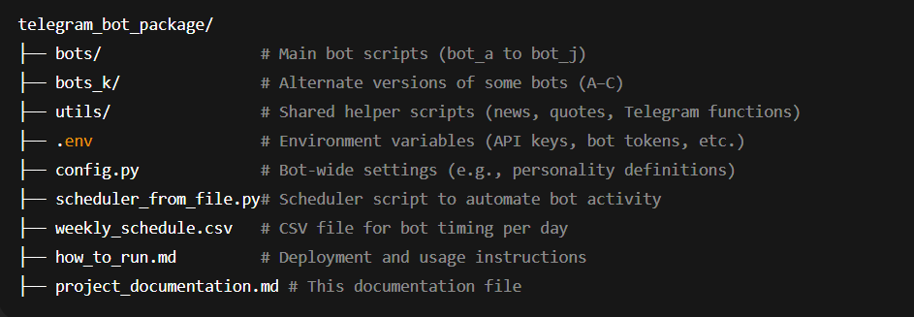
Environment Configuration
Sensitive credentials and runtime configurations are stored in the .env file. This allows clean separation between code and secrets, following best practices.
Required Fields in .env:
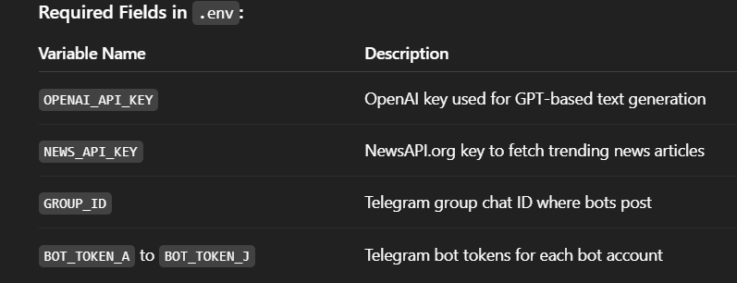
🔐 Security Reminder: Never commit .env to Git or share it publicly.
A .env.example file should be included in the repo to guide users in setting up their environment.
Bot Token Mapping
Each bot is tied to a specific bot token:
- Bot A → BOT_TOKEN_A
- Bot B → BOT_TOKEN_B
- ...
- Bot J → BOT_TOKEN_J
This separation ensures each bot has its own identity, enabling them to appear as unique human-like group members.
How Configuration Works
- config.py defines general settings like emoji sets, common styles, or logging parameters.
- config_k.py contains alternate settings for the bots in bots_k/.
- All bots and utility scripts read values from the .env using python-dotenv.
6. File Descriptions
This section provides a high-level overview of the key files and their roles in the Telegram AI Group Bots system:
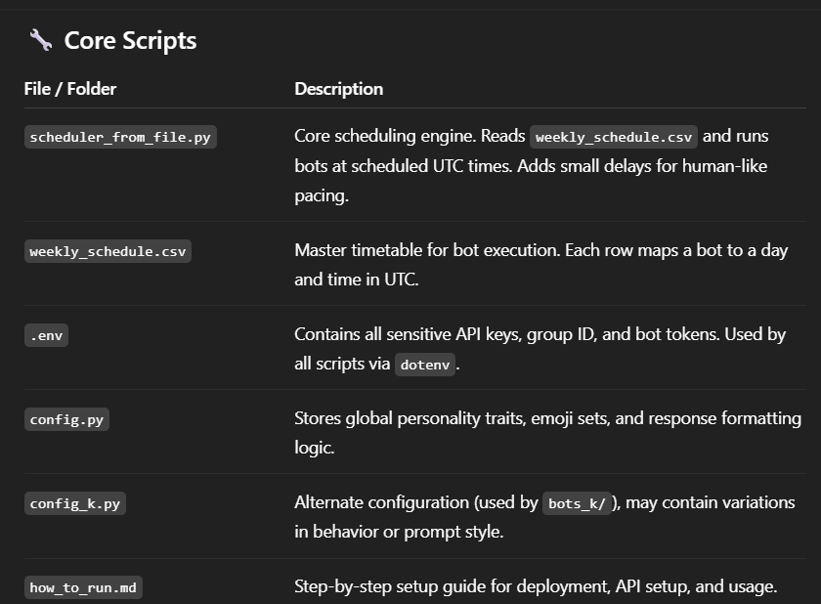
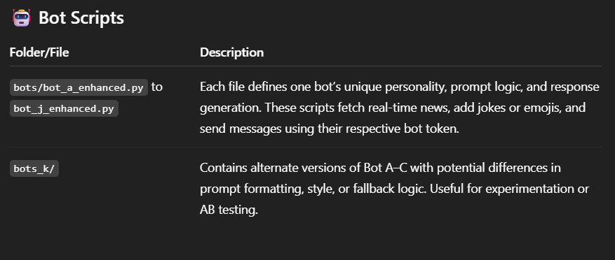
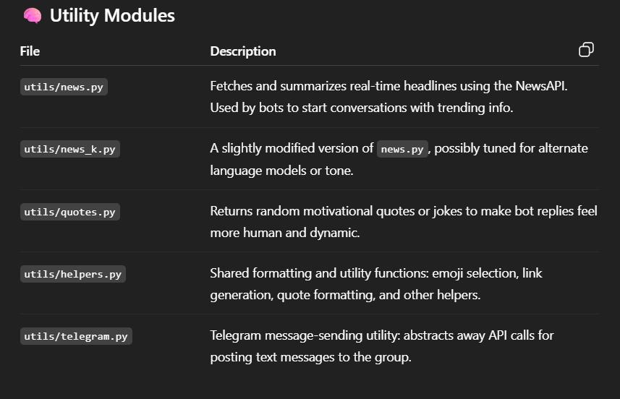
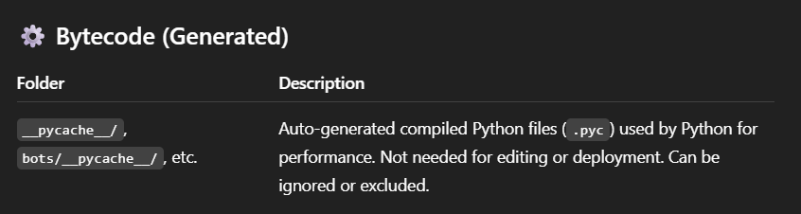
This modular structure ensures that bot logic, shared utilities, configuration, and scheduling remain cleanly separated — enabling easier debugging, extension, and reuse.
7. Security & API Usage
API Key Management
All API keys and sensitive credentials are stored securely in the .env file. This ensures that no secrets are hardcoded into the scripts, allowing safe deployment and better team practices.
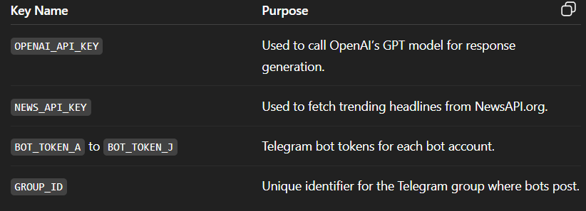
These variables are accessed in Python scripts using the python-dotenv package:
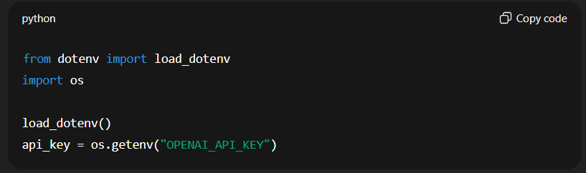
🔐 Note: The .env file should never be committed to version control systems (e.g., GitHub). Always use .gitignore to exclude it.
Telegram Bot Tokens
Each Telegram bot uses its own token, ensuring independent identities when posting. This makes them appear as individual group members with distinct behaviors.
- Tokens must be kept private.
- Each bot’s script (e.g., bot_a_enhanced.py) reads its token from the .env using BOT_TOKEN_A, BOT_TOKEN_B, etc.
Recommendations
- ✅ Use .env.example to show users how to structure their real .env.
- ✅ Rotate or revoke keys if credentials are ever exposed.
- ✅ Consider using environment variables via cloud provider secrets if deploying to platforms like Heroku, Railway, or AWS.
8. Run Instructions Summary
This section shows how to set up and run the Telegram AI Bots — step by step, with screenshot examples.
🧰 What You Need First
Before getting started, gather the following:
- ✅ A PC or laptop (Windows, Mac, or Linux)
- ✅ A Telegram group (where you’re the admin)
- ✅ 10 Telegram bot tokens
- ✅ An OpenAI API key (for GPT messages)
- ✅ A NewsAPI key (for fetching real headlines)
- ✅ Python 3.10+ installed (we’ll help with that next)
🧱 Step 1: Install Python
What you need to do:
- Visit https://www.python.org/downloads
2. Click Download Python 3.10+
3. Open the downloaded .exe file
4. IMPORTANT: On the first screen, check this box:
✅ “Add Python to PATH”
5. Click Install Now
6. Once complete, close the installer.
🗂️ Step 2: Extract the Project Folder
You should have a ZIP file: telegram_bot_package.zip
What you need to do:
- Right-click on it → choose Extract All
- Choose a folder like Downloads or Documents
- Open the folder named telegram_bot_package
🧱 Step 3: Install Required Libraries
What you need to do:
✅ Open a terminal window:
- On Windows:
  - Press Windows + R → type cmd → hit Enter
  - This opens Command Prompt
- On Mac:
  - Press Command + Space → type Terminal → hit Enter
- On Linux:
  - Press Ctrl + Alt + T

✅ Navigate to your project folder:
If you extracted it to Downloads, type:
 (Adjust path as needed)
✅ Install all required tools:
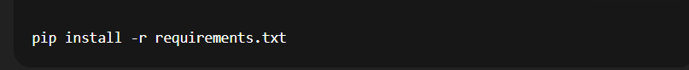
⚠️ If you get an error like pip not found, Python may not be installed correctly. Try reinstalling Python and ensure “Add to PATH” was checked.
🔐 Step 4: Set Up the .env File (Secret Keys)
What you need to do:
- In the project folder, locate .env.example
- Right-click → Copy
- Right-click again → Paste
- Rename the new file to .env
- Open .env in Notepad or VS Code
- Paste your values like this:
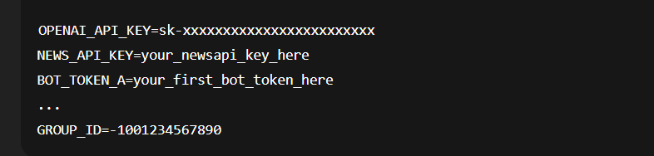
🆔 How to find your Telegram Group ID:
- Go to your group
- Add this bot: @getidsbot
- It will reply with your group’s ID (starts with : “-100...”)
🆔 Optional Ways to Find Your Telegram Group ID:
- Use a Python script to print message.chat.id
- Call getUpdates from Telegram Bot API and check chat.id
- Use Postman or curl to call the Bot API and extract group ID from JSON response
🤖 How to Create a Telegram Bot Token using BotFather:
To make a bot post messages in your group, you need a special key called a bot token. You can create one for free using BotFather, Telegram's official bot manager.
✅ What you need to do:
- Open Telegram app on your phone or computer
- Search for @BotFather
- Click on it and then tap Start
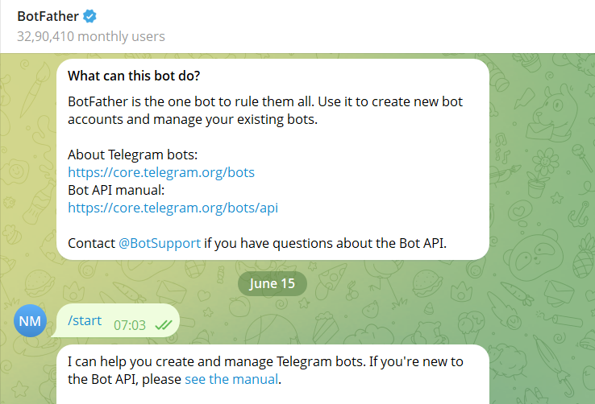
- Type or tap:
- BotFather will ask:

- Next, it will ask:

- Once accepted, you’ll receive a message like this:
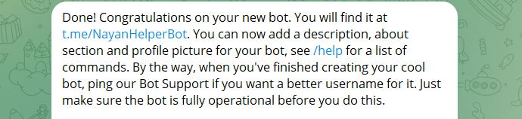
- ✅ Copy that token — it looks like this:
- Paste it into your .env file like:

10.Repeat this process 10 times (create 10 bots) and store them as:
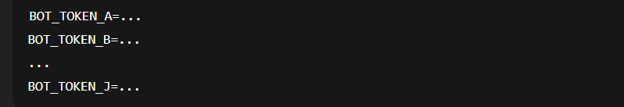
📅 Step 5: Edit the Bot Schedule (Optional)
What you need to do:
- Open weekly_schedule.csv in Excel or Google Sheets
- You’ll see something like this:
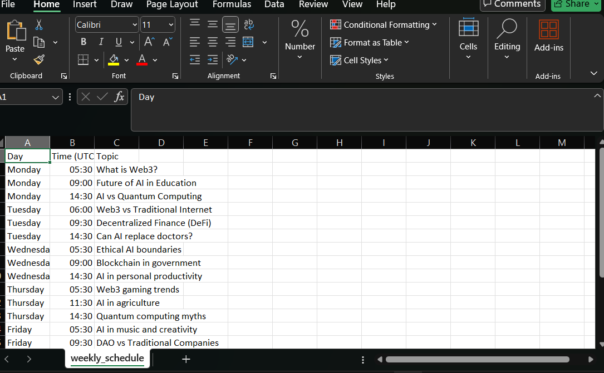
You can:
- Change times
- Add new rows
- Remove bots for certain days
⏰ Remember: Time is in UTC. Use worldtimebuddy.com to convert to your local timezone.
▶️ Step 6: Run the Scheduler (Start All Bots)
What you need to do:
In your terminal (still inside the project folder), run:
✅ If everything is correct:
- Bots will send real messages to your group
- You’ll see success messages in the terminal
💡 Keep this terminal open. Closing it will stop the bots.
✅ Congratulations! Your Telegram AI bots are now:
- Scheduled ✅
- Speaking like humans ✅
- Posting real-time news, quotes, and engaging content ✅

